Introduction
This report will outline the design process of a relational database for a new online video game marketplace, to be positioned as a competitor to “Steam”. The platform will allow users to purchase games, play online with friends, send messages, and write reviews. This report will document the transition from unnormalized to Boyce-Codd Normal Form (BCNF) and key decisions made along the way. To keep terminology consistent, I will be using tables and columns and rows to describe the various entities, attributes, and records within the database.

Database Design
Conceptual Stage
I began the process by documenting some conceptual queries that might be made by users of the platform and by admins or developers, alongside the kind of tables that would be required for the data such queries would need to store and update data.
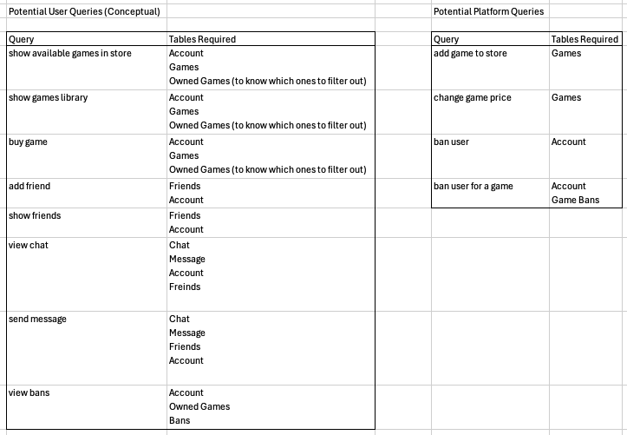
Once the essential data requirements were identified, a mock table was created in an unnormalized format to represent the initial structure that will be worked off of.
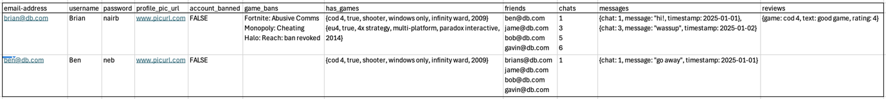This data is referred to as unnormalized because it does not meet the requirements for the 1st stage of normalisation (1NF) Which are:
- All fields contain only atomic data.
- There are no repeating groups
- Each row in the table has a unique identifier
It contains repeating groups, such as the friend’s column. Some fields are non-atomic such as the chat’s column. There are also instances of redundant data, such as repeated references to games across different fields.
Data in this format can lead to various anomalies when inserting, updating or deleting rows, some examples in this data include:
- Insertion: A game cannot be created individually; it can only exist if an account owns it or is banned in it
- Update: Modifying a game title requires changing it in multiple cells and rows
- Delete: If a user is the only person that owns a game and that user is deleted, then there will be no record of that game.
Normalization of Data and ERD Development
To address these issues discussed in the conceptual stage I must first model the data into a format that meets the requirements of 1NF. Which will involve splitting most of the columns into their own individual tables. I began by creating conceptual models that do not contain any specifics about attributes of data types and focus only on the relations between entities.
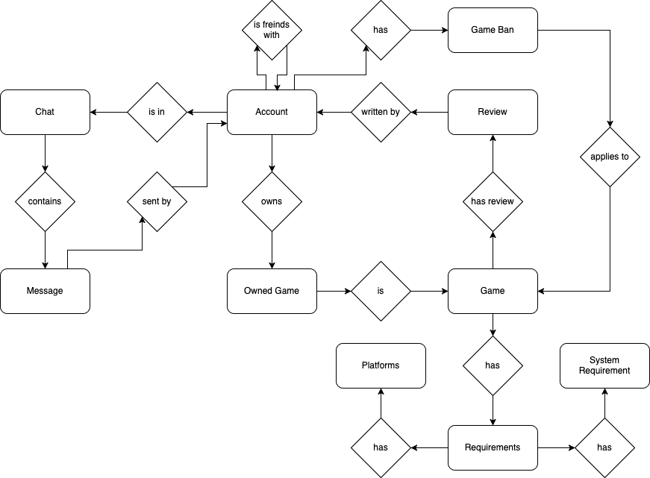
[REDO CONCEPTUAL MODEL TO MATCH 1NF DESIGN]
Rectangles representing Entities and Diamonds representing the type of relationship between them, this allowed an easy transition into an ERD (Entity Relationship Diagram) that meets the requirements for 1NF.
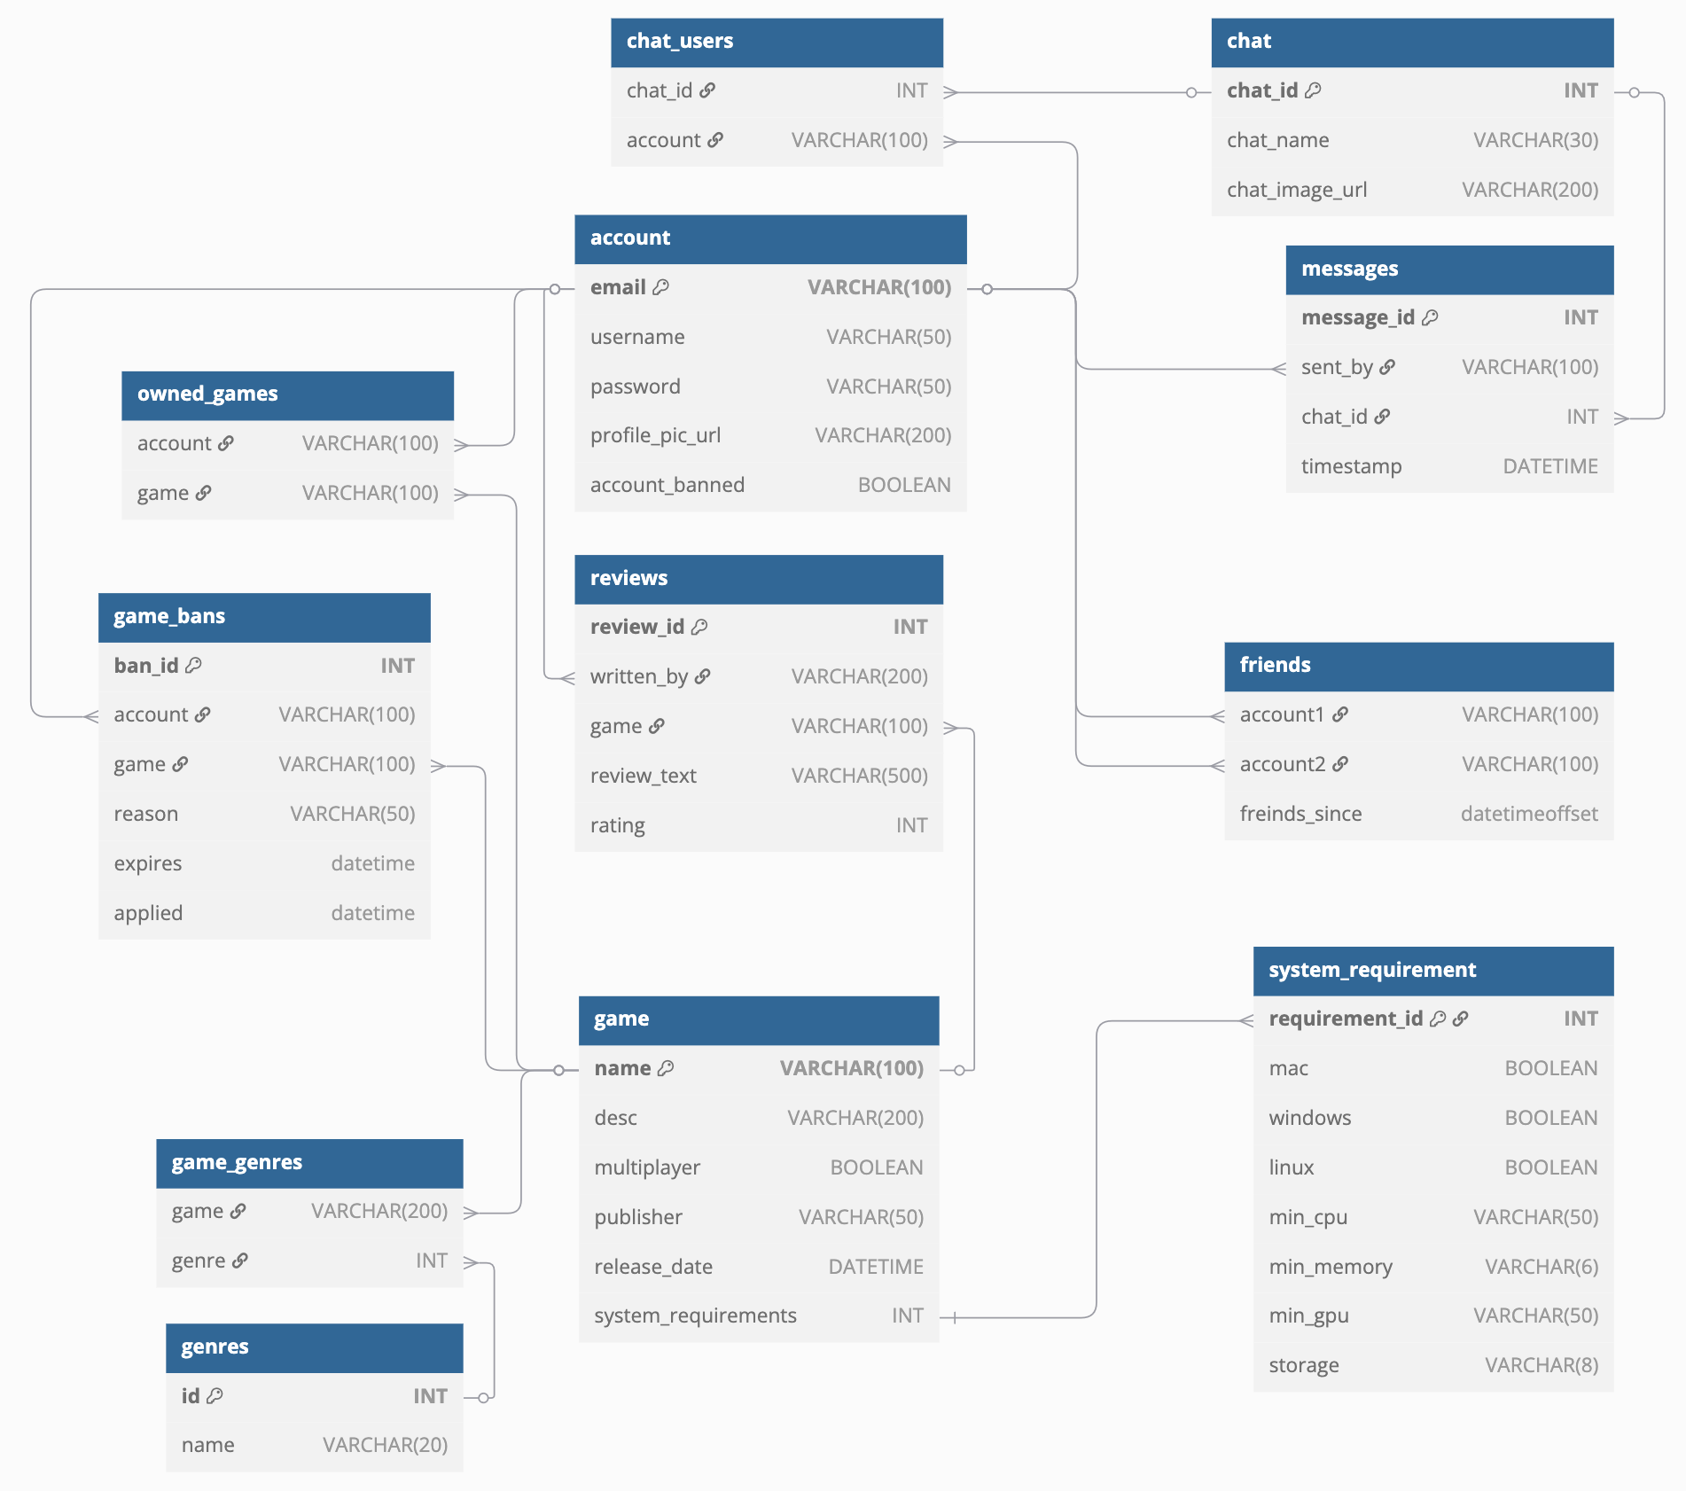
Some assumptions were made here when checking the requirements for 1NF, for example, email was chosen as the primary key for the account table on the assumption that it will be unique. In the case of this product, the email will be unique and only available for use once, however if this was not the case. Another attribute would need to be used or created as a primary key. This also applies to the game entity where we are assuming game will be unique, this can potentially lead to additional problem which will be addressed later in the normalization process. There are some situations such as friends, owned games and accounts in a chat where a many to many relationships needed to represent. For this I used a ‘junction’ table which allowed me to keep data atomic and composite keys are used as the primary key. Whilst in the account and game tables natural keys were able to be used as the primary keys, in other tables a surrogate key had to be created as there was no way of uniquely identifying the row.
The next stage is 2NF which requires that all non-key attributes are fully dependant on the primary key, since the ERD design for 1NF already meets these requirements, no changes were required at this time. The same also went for 3NF, which requires that all attributes in the table be functionally dependant on the primary key and contain no transitive dependencies which is when an attribute is dependent on another non-key attribute which is dependent on a key attribute. Since in all of my tables, all non-key attributes are fully dependant on the whole primary key and nothing else, this requirement is also met, meaning it also meets 3NF.

